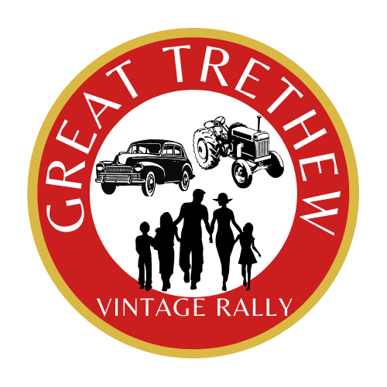

**Sponsorship Packages 2024**

Great Trethew Vintage Rally

24th, 25th & 26th August 2024

Plans are well underway for the 2024 Great Trethew Vintage Rally, which takes place over the August bank holiday weekend attracting approx 5000 people over the three days of the rally. As is increasingly the case the costs of putting on this years rally have escalated and your contribution as a local business owner is needed now more than ever to support this not for profit event.

Last year with your help we were able to donate over £4000 to local causes.

We are pleased to announce that we once again are publishing our own Rally programme. This will be available electronically and printed, which provides a fantastic opportunity for businesses to support and advertise with us in a different ways. Our suggested sponsorship and advertising levels are below.

If you would like to discuss any of these further, please contact

Chairman: Tony Ball 07565 503 348 or Treasurer: Sue Gillbard 07811 851 497

**Trethew Rally friend - £50** advertise your banner in the main ring or perimeter fences or a quarter page advert in our programme and a free one-day pass for two people will be provided.

**Trethew Rally supporter - £65** advertise your banner and a quarter page advert in our programme and a free one-day pass for two people will be provided.

**Trethew Rally Entertainment Sponsor - £125** help us put on quality acts throughout the weekend and you can advertise your banner around the main ring and have a free one-day pass for four people. You can also have the option to include a quarter-page advert in our programme.

**Trethew Rally Section Sponsor - £250** sponsor a section and you can have full availability to sponsor around the designated section. You can also put a banner in the main ring and we will provide free one day passes for six people. You will also have the opportunity to enter a half page programme advert with the section entries. Please speak to Tony or Sue for available sections.

**Agricultural Utility Vehicle Sponsorship** – sponsor an agricultural utility vehicle for the weekend. These vehicles are essential for showground directors in providing a quick response to all areas of the showground. If you can help us with these vehicles, please contact Tony Ball for more information.

**Programme adverts only** – (quantity of comp tickets available dependent on advert size).

Back cover or inside front cover £150

Full page £100

Half page £50

Quarter page £25